DADE COUNTY ASSOCIATION OF FIRE FIGHTERS CHARITIES
8000 N.W. 21st Street, Suite 222, Miami, FL 33122-1605
Phone: (305) 593-6100 – Fax: (305) 591-9654

William McAllister IV | Brian Lynch | Lisa Bullard | Paul Blake | Christopher Fink
President | First Vice President | Second Vice President | Treasurer | Secretary

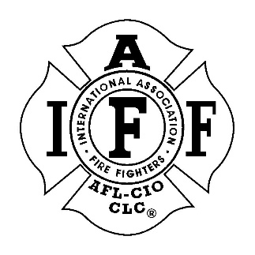
CHARITIES REQUEST FORM

DATE
MEMBER REQUESTING
CHARITY NAME
ORGANIZASTION TYPE AND TAX ID NO.
REASON/EVENT
AMOUNT REQUESTING
ORGANIZATION ADDRESS
PHONE
CONTACT PERSON (if known)
APPROVAL TYPE DATE AMOUNT
(E-Board Meeting, Regular Meeting, phone poll, etc.)

CHARITIES BOARD DECISION
- Approve
- Decline

VERIFICATION THAT MEMBER DONATES TO
CHARITIES FUND (Initials of person who verified)

CHECK PAYABLE TO

CHECK #

